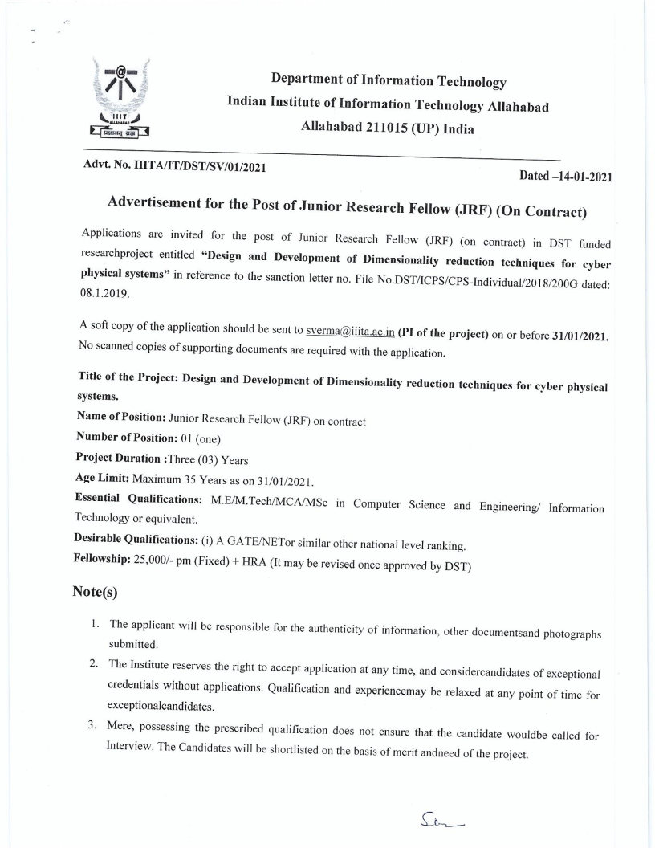
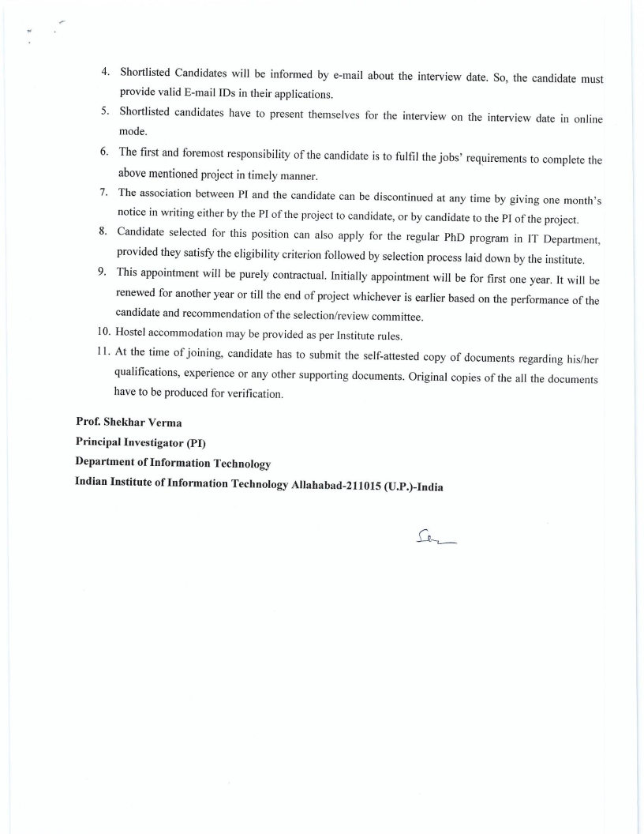

Department of Information Technology
Indian Institute of Information Technology Allahabad
Allahabad 211015 (UP), India

______________________________________________________________
Advt. No. IIITA/IT/DST/SV/01/2021
For office use only
Application No…………….

APPLICATION FORM

Dated…………………

Research Project Entitled- “Design and Development of Dimensionality reduction techniques for cyber physical systems”
File No. : DST/ICPS/CPS-Individual/2018/200G
Funding Agency:Department of Science & Technology, Ministry of Science and Technology, New Delhi
Name of P.I.: Prof. Shekhar Verma
Name of position: Junior Research Fellow (on contract)
Department/Section:Information Technology

- Name of the Candidate (In Capital):

- Sex (Male/Female):

- Marital Status (Married/Unmarried):

- Date of Birth:

- Age (as on last date of application): __________Years _________Months _________Days

- Father’s/Husband’s Name:

- Present/Contact Address:

- Permanent Address:

- Mobile No:

- E-mail:

- Nationality:

- Category Gen/SC/ST/OBC/PH:

- GATE/NET

Branch | Year | Valid up to | Percentile (& Score) | All India Rank

- Educational Qualification (10th onward):

Qualification | Subject/Discipline | Board/Institute/Univ. | Year of passing | % of marks | Division
10th

12th

Diploma, if any

B.E./B.Tech

M.E./M.Tech

- Summary of M.E/M.Tech/MSc. Thesis (Maximum 150 words):Enclose a separate sheet
- Research Publications (Maximum Best 5): Enclose a separate sheet
- Details of Experience in chronological order. Enclose a separate sheet
- Any other information: Enclose a separate sheet
- Indicate whether you propose to register for higher degree at IIITA, Allahabad: Yes/No
(Name of higher degree is Ph.D.)

DECLARATION

I hereby declare that all the statements made in this application are true and complete and nothing has been
concealed/ distorted. I am aware that, if at any time I am found to have concealed/distorted any material information, my engagement is liable to be summarily terminated without notice.

Place: Signature of the Applicant
Date:

